**$devis_name$**



$devis_description$

**Highlights**

$devis_date$

**$devis_guest$**

**$devis_number$**

**Devis No.**

**$devis_prix$**

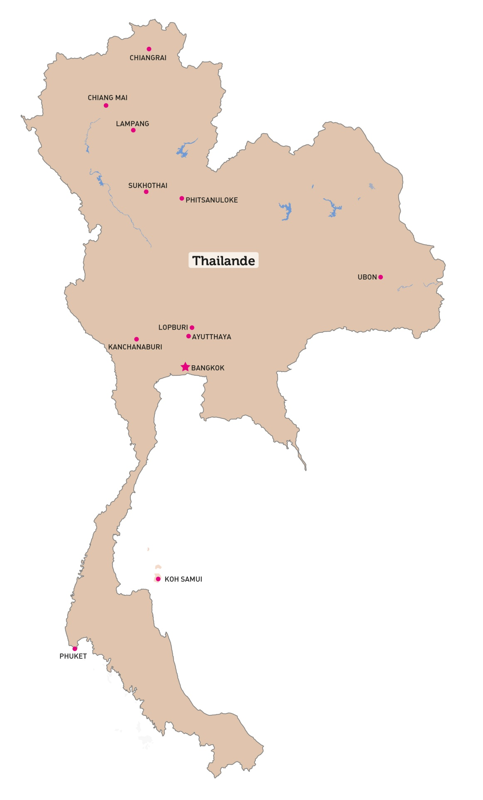

$sale_detail$

## Brief itinerary

$devis_table_programe$

**Meals**| **B**Breakfast |**L** Lunch |**D**Dinner

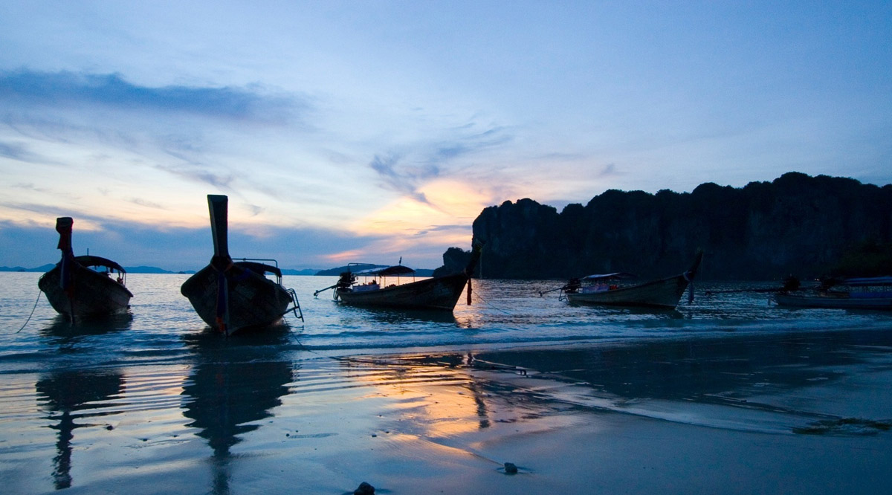

 Full itinerary

$devis_detail$

## Tour price

$devis_table_tarif$

$devis_promotion$

## Booking conditions

$devis_condition$



About us

Amica Travel stands out from the crowd by offering **unique benefits** to our customers.Please visit the following link to see how we are different from the rest:

<http://en.amica-travel.com/about-us/why-amica-travel>



Our solidarityprojects

Traveling with Amica Travel means choosing an organization and a method of travel that respects the cultures, the traditional ways of life, and the regional environment.Through our solidarity travel initiatives, we provide support for local communities. Please check this following link to have more information about current projects

<http://en.amica-travel.com/solidarity-travel>

Our customers speak about us



If you want to know what our formercustomers speak about us, please click the following links:

<http://en.amica-travel.com/testimonials>

<http://www.petitfute.uk.com/travel-transport/local-agency-tourist-guide/amica-travel/e-143513.html>



Follow us on

[](https://www.facebook.com/amicatravel.en)[](http://www.pinterest.com/amicatravelen/)[](https://twitter.com/AmicaTravel_En)[](http://www.youtube.com/channel/UCmHPdAvw4BuEsRTbp8TxP9Q)[](http://www.amica-travel.com/upload/assoc/pata.jpg)[](http://ustoa.com)[](http://www.atofi.com/asie/vietnam)[](http://www.ecotourism.org/amica-travel)[](http://www.adventuretravel.biz/about/atta-members/)[](http://www.amica-travel.com/upload/assoc/ASTAcert.pdf)



In partnership with